# Refrigeration Temperature Simulator - User Manual

## Step 1: Collect Calibration Datasets

Prepare two temperature timeseries for calibrating the simulator:

1. Closed-door (steady state) condition, characterized by a steadily oscillating temperature curve as in Figure 1

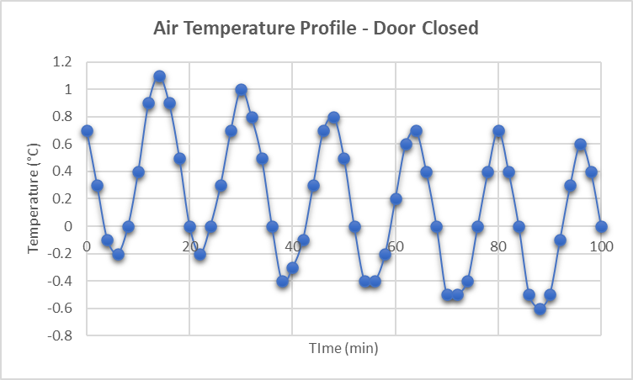

Figure 1 Plot of measured air temperature in the middle of the refrigeration compartment of a domestic refrigerator set to 0 °C, under steady-state (no door opening) condition

1. Open-door (transient) condition, capturing the temperature fluctuation before, during, and after the compartment door is opened for a relatively long period of time e.g., 10-15 minutes, as in Figure 2

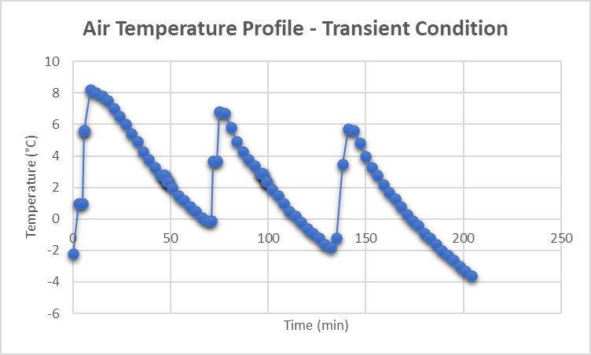

Figure 2 Plot of measured air temperature in the middle of the refrigeration compartment of a domestic refrigerator set to 0 °C, under transient (door opening) condition

## Step 2: Clean Calibration Datasets

Clean the temperature history to be used for system identification:

1. Delete regions of sensor temperature transition from room temperature to fridge temperature
2. If the sampling rate is not constant, resample the data by interpolation to get a fixed sampling interval
3. Convert date-time stamps to minutes starting from zero

## Step 3: Install Additional Matlab Packages

Install additional Matlab tools: System Identification Toolbox and Simulink

## Step 4: Prepare Input Files

Download the zipped file and extract it in any folder. Open the ‘Input Files’ folder.

The Input files folder contains 4 excel workbooks in which the user must insert the inputs to the program. The description and purpose of each input file is given in the table below.

Table Description of Input Files

|  |  |  |
| --- | --- | --- |
| File name | Contents | Purpose |
| No door openings-cleaned.xlsx | Ambient temperature timeseries inside the fridge while the fridge door is closed. | Training dataset for system identification |
| door opening-cleaned.xlsx | Ambient temperature timeseries inside the fridge for a duration involving instances of the fridge door being opened and closed any number of times | Identification of system behavior when door is opened |
| SensorFeed.xlsx | * Instants (in minutes counting from the start of the trip) at which the fridge door was is expected to be opened/closed | * Record the times at which the door was opened/closed, whether the events were monitored or simulated |
| SysIDSetupData.xlsx | * Six plant-controller parameters to be deduced by the user offline (prior to running the program) from the open-door and closed-door timeseries * Simulation time | * Plant-controller identification * Defining the total simulation time |

### No door openings-cleaned.xlsx

The workbook contains only one worksheet containing the cleaned ambient temperature timeseries for steady-state, closed-door condition, where time is in minutes, starting from zero, and sampled at a fixed sampling rate. The data starts in cell A3:

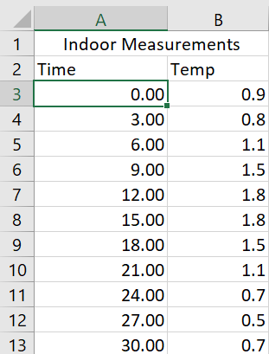

### door opening-cleaned.xlsx

Likewise, this workbook contains only one worksheet containing the cleaned ambient temperature timeseries for transient condition involving door openings, where time is in minutes, starting from zero, and sampled at a fixed sampling rate. The data starts in cell A3:

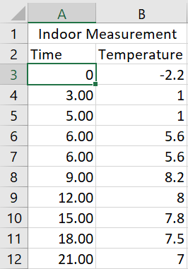

### SensorFeed.xlsx

This workbook contains the worksheet ‘DoorOpen’. If the fridge door is opened and closed in a simulated trip, then the user must enter the instants at which the door is opened and closed in the second worksheet ‘DoorOpen’, where the times are in minutes, assuming the trip starts at 0 minutes.

If door opening is not expected, leave the data table blank:

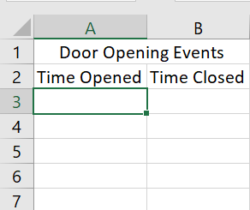

### SysIDSetupData.xlsx

This workbook contains only one worksheet. The user must specify the following parameters before running the program:

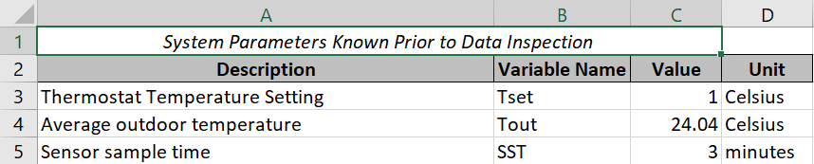

And in the case of pre-planning: The simulation time, which is the expected trip time:



The remaining parameters (ODTRR, CDTRR, and CST) are identified by inspecting cleaned open-door and closed-door temperature timeseries. The values of ODTRR, CDTRR and CST saved in the excel sheet are considered default values of these variables, unless the user specifies a different value at the command line prompt. The prompt for the values of ODTRR, CDTRR and CST will appear during program execution if the user chooses to identify a new system.

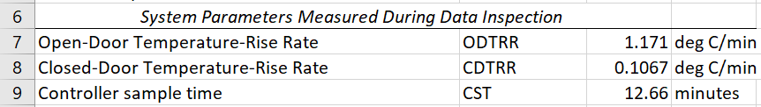

The user may:

1. Inspect both timeseries in excel (and subsequently enter the values of the 3 remaining parameters in this excel sheet) prior to running the program, or
2. Inspect both timeseries during program execution and enter the values of the 3 remaining parameters in the Matlab command line when prompted. The latter option is preferred if the user is identifying the plant for the first time, as Simulink’s scope tool is easier than using Excel for identifying slopes and time differences between any two points in the data.

## Step 5: System Identification

In the extracted folder, open the script named ‘SysIDPrepWS_v18.mlx’, change the Matlab search path to the extracted folder, then click on the ‘Run’ button, or press F5 to run this script.

The system identification tasks will commence in the background. First, the open-door and closed-door temperature timeseries will be displayed in Simulink’s scope tool, and then the user will be prompted to enter the values of CDTRR, ODTRR, and CST in the command line.

To estimate **ODTRR**, which is the average temperature-rise rate when the door is opened, you may select any cycle in the stable region and estimate the upward slope at a time when the door is known to have been opened. Click on “Cursor measurements” , then move pointer 1 to the trough of the cycle, and pointer 2 to the first peak on the right of pointer 1. From the figure below, the ODTRR is about 1.313 degrees Celsius per minute (don’t convert between seconds and minutes).

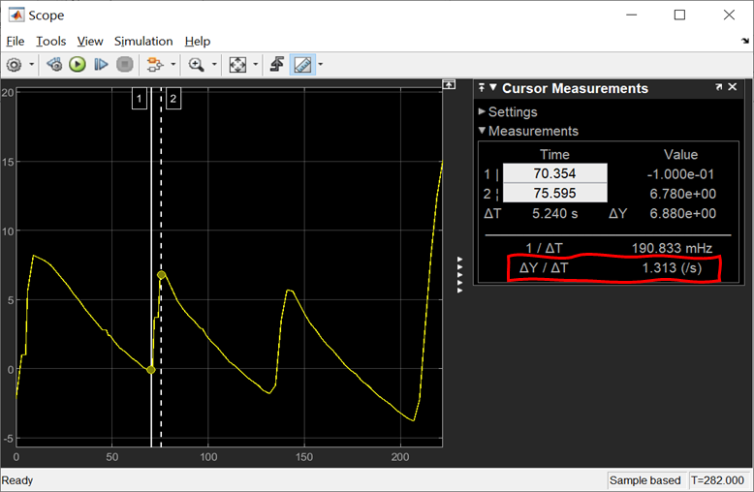

Figure Estimation of ODTRR (time in minutes)

Type 1.313 at the command prompt and click Enter:



An automatically generated plot of the closed-door dataset appears. Estimate the temperature-rise rate when the door is closed (CDTRR). From the figure below, **CDTRR** appears to be 0.125 degrees Celsius per minute (do not convert between minutes and seconds).

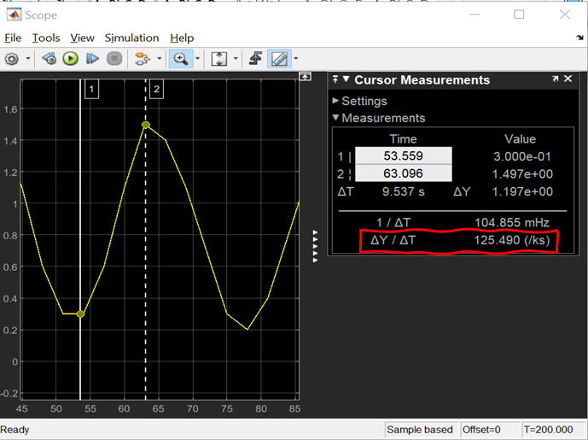

Figure Estimation of CDTRR (time in minutes)

At the next command prompt, enter 0.125 and hit Enter:

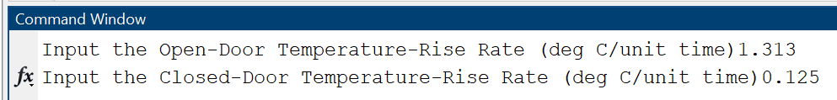

Estimate the sample time of the discrete controller (**CST**) by measuring the time between a peak and the following trough in the stable region. Move pointer 1 to the peak of a cycle, and pointer 2 to the first trough on the right of pointer 1. The figure below shows that the discrete controller has a sample time of about 12.47 minutes.

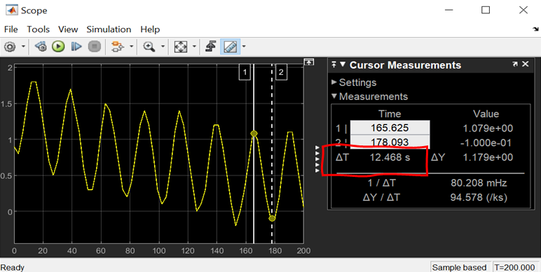

Figure 5 Identifying the discrete controller sample time from ambient temperature timeseries measured under steady-state (no door-opening) condition

Enter 12.47 at the third command prompt and click Enter:

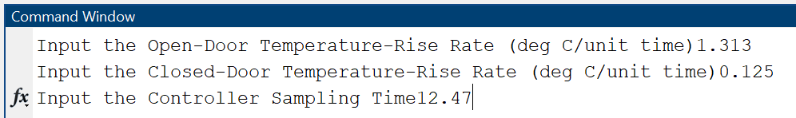

Note that if the user enters nothing (by hitting Enter key) at the command-line prompt for a variable, its corresponding default value in ‘SysIDSetupData.xlsx’ will be used as a default value.

Next, an automatically generated plot shows the *Hankel singular values* for state-space models of the orders between 1 and 10. States with relatively small Hankel singular values can be safely discarded. (Red is usually the recommended choice for model reduction). Select the model order in the Chosen Order list and click Apply.

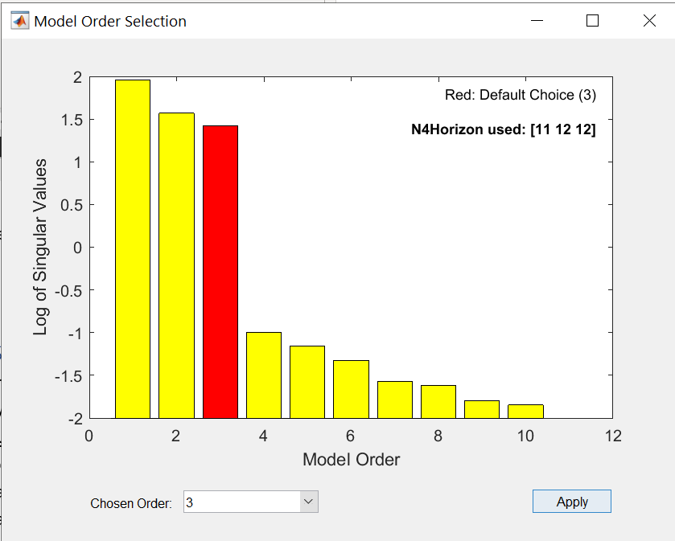

Figure Example of an automatically generated plot of Hankel Singular Values

With the completion of this step, the calibration of the Refrigerator Temperature Simulator is finally complete.

The output of the system identification step is a graph comparing the training data (closed-door dataset provided by the user) to the response of the identified state-space model. The legend shows the NRMSE fitness value. In addition, an idss object in the workspace named ‘sys’ appears in the workspace, which represents the identified state-space model.

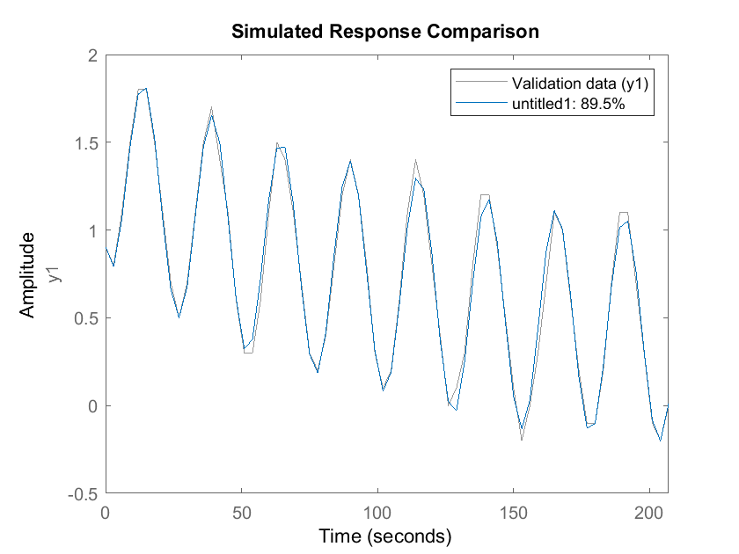

Figure Comparison of estimated model output to measured output

## Step 6: Temperature Simulation

Having performed the previous step, open the script named ‘ControlSysSetup_v18.mlx’, and run it. The output is the simulated ambient temperature in the refrigeration system to which the simulator was calibrated. Below are example outputs for the case of no door opening, and for repeated door opening.

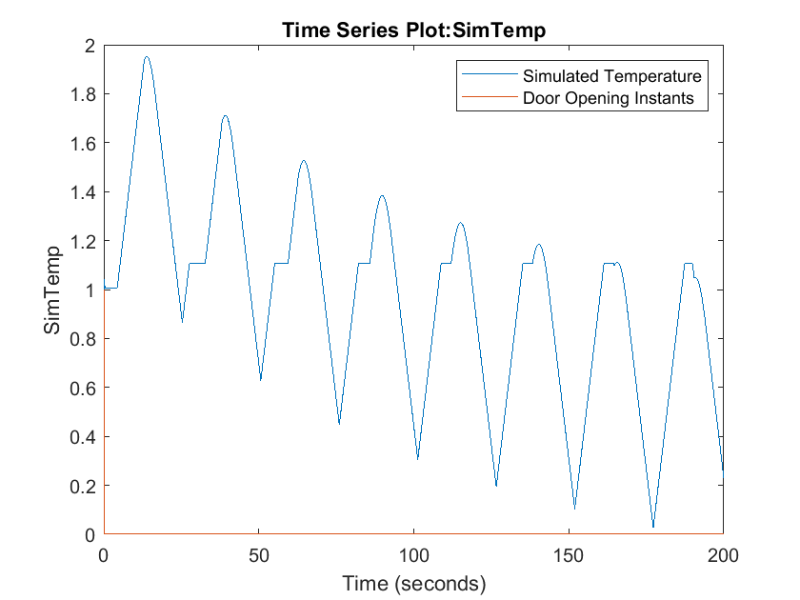

Figure Plot of simulated temperature history under closed-door condition

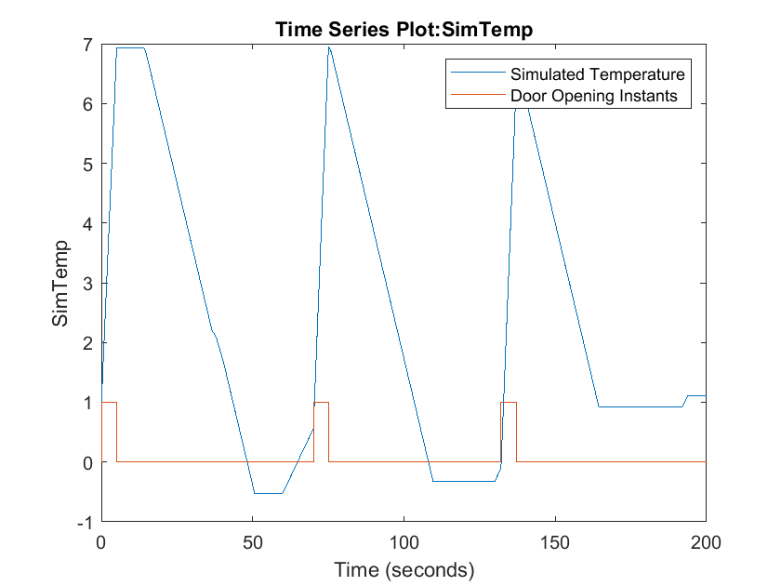

Figure Example plot of simulated temperature history under open-door condition